Supplementary materials

*Table S1: List of priors used in Bayesian, spatially explicit unmarked population density models for four species. Computed from presence absence data at camera stations from the mid-coast of NSW, Australia (2022/2023).*

|  |  |  |  |
| --- | --- | --- | --- |
|  | Sigma | g0 | M |
| Dingo | (3,2) (gamma distribution) | (0,1) det intercept on probability scale | 200 |
| Fox | (5,7) gamma distribution | (0,1) det intercept on probability scale | 200 |
| Quoll | (5,7) gamma distribution | (0,1) det intercept on probability scale | 200 |
| Goanna | (2,4) gamma distribution | (0,1) det intercept on probability scale | 800 |

*Table S2: Model diagnostics and outputs of* *Bayesian, spatially explicit unmarked population density models for four species, from camera data on the mid-coast region of NSW, Australia (2022/2023). Alhpa1 = detection probability at baited cameras (relative to trail cameras). Mean.p = detection intercept. Psiu = detection probability. Sigma = parameter related to home range. Nu = estimated individuals across the study area. D = density (individuals km*-2*). Rhat = gelman-Rubin diagnostic. N.eff = effective sample size.*

|  |  |  |  |  |  |  |  |  |  |
| --- | --- | --- | --- | --- | --- | --- | --- | --- | --- |
|  | Species | mean | sd | X2.5. | X50. | X97.5. | Rhat | n.eff | Mode |
| alpha1 | Fox | -3.10362 | 0.342525 | -3.79475 | -3.09663 | -2.46167 | 1 | 2804 |  |
| mean.p | Fox | 0.241665 | 0.065992 | 0.130424 | 0.235497 | 0.389995 | 1.02 | 335 |  |
| psiu | Fox | 0.320479 | 0.10842 | 0.169182 | 0.299926 | 0.599319 | 1.01 | 367 |  |
| sigma | Fox | 0.475682 | 0.072546 | 0.349297 | 0.47001 | 0.654837 | 1.03 | 189 |  |
| Nu | Fox | 64.2532 | 20.89513 | 36 | 60 | 120 | 1.01 | 349 |  |
| D | Fox | 0.358756 | 0.116668 | 0.201005 | 0.335009 | 0.670018 | 1.01 | 349 | 0.29681 |
| alpha1 | Dingo | -2.35611 | 0.203399 | -2.763 | -2.35174 | -1.97187 | 1 | 4868 |  |
| mean.p | Dingo | 0.085197 | 0.024293 | 0.047182 | 0.082183 | 0.140118 | 1.02 | 305 |  |
| psiu | Dingo | 0.286592 | 0.175525 | 0.07441 | 0.245546 | 0.783576 | 1.02 | 90 |  |
| sigma | Dingo | 1.208078 | 0.480379 | 0.479691 | 1.114661 | 2.286639 | 1.03 | 57 |  |
| Nu | Dingo | 57.3082 | 34.94616 | 16 | 49 | 157 | 1.02 | 75 |  |
| D | Dingo | 0.251214 | 0.153189 | 0.070137 | 0.214794 | 0.688219 | 1.02 | 75 | 0.133187 |
| alpha1 | Quoll | 1.864933 | 0.371388 | 1.168524 | 1.850682 | 2.632959 | 1.02 | 647 |  |
| mean.p | Quoll | 0.025246 | 0.010586 | 0.009891 | 0.023543 | 0.051493 | 1.02 | 288 |  |
| psiu | Quoll | 0.325335 | 0.128526 | 0.152351 | 0.299863 | 0.685179 | 1.04 | 295 |  |
| sigma | Quoll | 0.428161 | 0.078697 | 0.282449 | 0.422866 | 0.635609 | 1.05 | 172 |  |
| Nu | Quoll | 65.17623 | 25.05968 | 33 | 60 | 136 | 1.04 | 259 |  |
| D | Quoll | 0.350504 | 0.134766 | 0.177467 | 0.322667 | 0.731379 | 1.04 | 259 | 0.2843 |
| alpha1 | Goanna | 1.672465 | 0.16494 | 1.354386 | 1.6716 | 2.00068 | 1.01 | 871 |  |
| mean.p | Goanna | 0.025023 | 0.005367 | 0.015721 | 0.024581 | 0.036982 | 1.04 | 240 |  |
| psiu | Goanna | 0.366767 | 0.073087 | 0.240464 | 0.361767 | 0.522221 | 1.01 | 452 |  |
| sigma | Goanna | 0.406965 | 0.044342 | 0.355316 | 0.400106 | 0.484055 | 1.04 | 298 |  |
| Nu | Goanna | 293.7471 | 57.01312 | 197 | 290 | 416 | 1.01 | 426 |  |
| D | Goanna | 1.640131 | 0.318332 | 1.099946 | 1.619209 | 2.322728 | 1.01 | 426 | 1.58 |

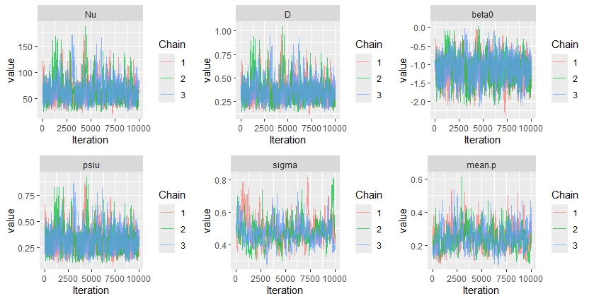

*Figure S1a: Traceplots from* *Bayesian, spatially explicit unmarked population density model for foxes, from camera data on the mid-coast region of NSW, Australia (2022/2023). Plots show values from each iteration and the value estimated for each parameter modelled, for each chain (n=3 chains). Alhpa1 = detection probability at baited cameras (relative to trail cameras). Mean.p = detection intercept. Psiu = detection probability. Sigma = parameter related to home range. Nu = estimated individuals across the study area. D = density (individuals km*-2*)*

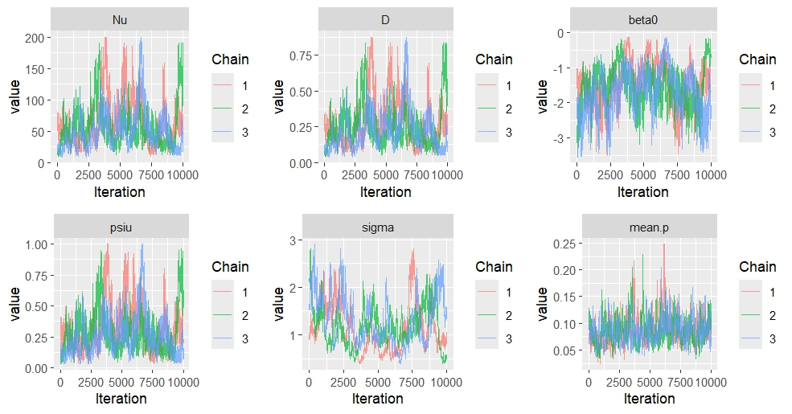

*Figure S1b: Traceplots from* *Bayesian, spatially explicit unmarked population density model for dingoes, from camera data on the mid-coast region of NSW, Australia (2022/2023). Plots show values from each iteration and the value estimated for each parameter modelled, for each chain (n=3 chains). Alhpa1 = detection probability at baited cameras (relative to trail cameras).Mean.p = detection intercept. Psiu = detection probability. Sigma = parameter related to home range. Nu = estimated individuals across the study area. D = density (individuals km*-2*)*

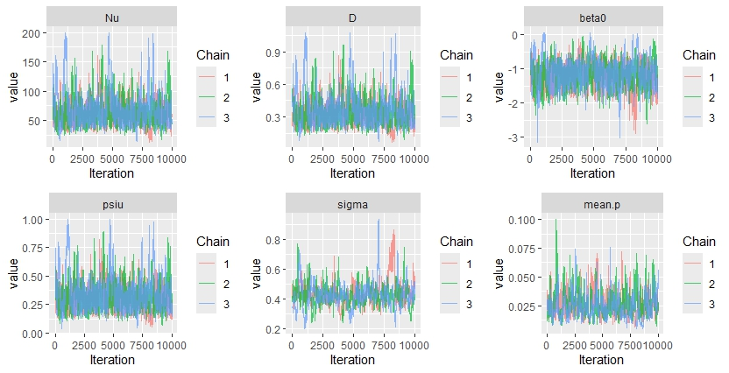

*Figure S1c: Traceplots from* *Bayesian, spatially explicit unmarked population density model for quolls, from camera data on the mid-coast region of NSW, Australia (2022/2023). Plots show values from each iteration and the value estimated for each parameter modelled, for each chain (n=3 chains). Alhpa1 = detection probability at baited cameras (relative to trail cameras). Mean.p = detection intercept. Psiu = detection probability. Sigma = parameter related to home range. Nu = estimated individuals across the study area. D = density (individuals km*-2*)*

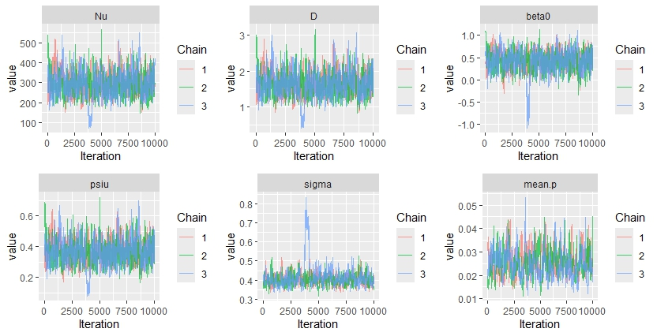

*Figure S1d: Traceplots from* *Bayesian, spatially explicit unmarked population density model for lace monitors, from camera data on the mid-coast region of NSW, Australia (2022/2023). Plots show values from each iteration and the value estimated for each parameter modelled, for each chain (n=3 chains). Alhpa1 = detection probability at baited cameras (relative to trail cameras). Mean.p = detection intercept. Psiu = detection probability. Sigma = parameter related to home range. Nu = estimated individuals across the study area. D = density (individuals km*-2*)*

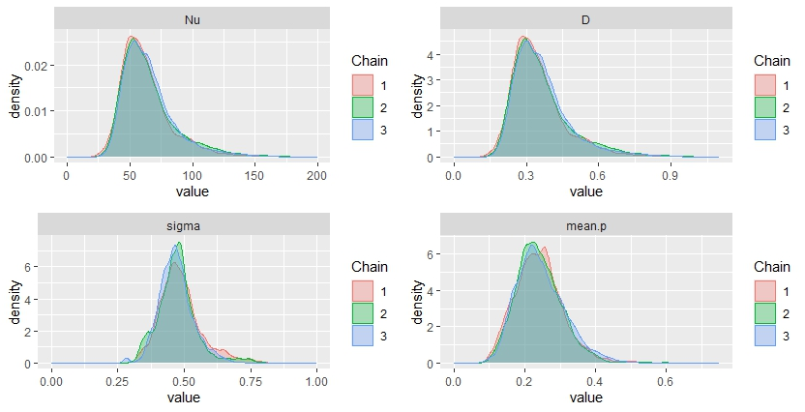

*Fig S2a: Distribution of posterior samples from 30,000 iterations of Bayesian, spatially explicit unmarked population models for foxes, derived from camera data on the mid-coast of NSW, Australia. Nu = estimated number of individuals, D = density, sigma = a parameter related to home range, mean.p = detection probability intercept.*

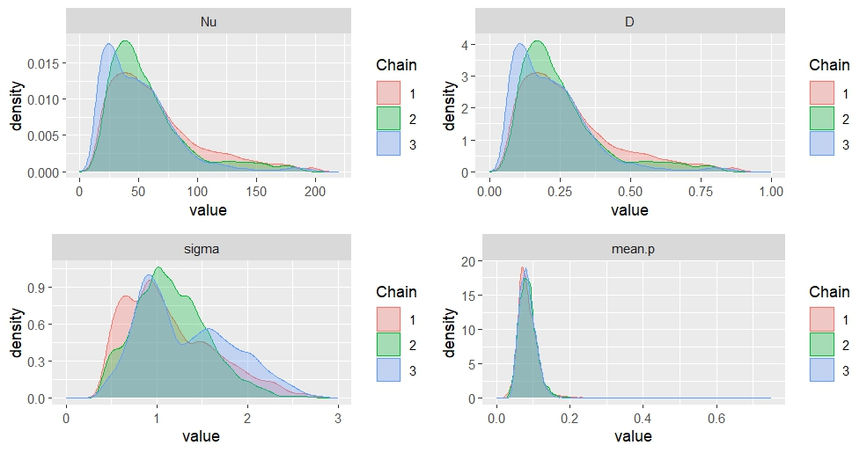

*Fig S2b: Distribution of posterior samples from 30,000 iterations of Bayesian, spatially explicit unmarked population models for dingoes, derived from camera data on the mid-coast of NSW, Australia. Nu = estimated number of individuals, D = density, sigma = a parameter related to home range, mean.p = detection probability intercept.*

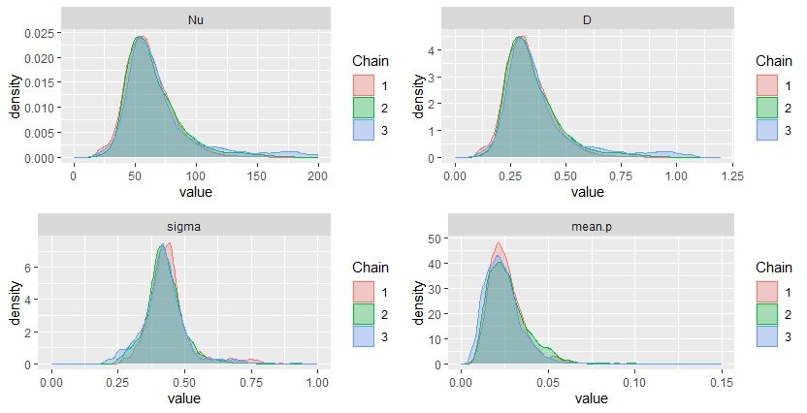

*Fig S2c: Distribution of posterior samples from 30,000 iterations of Bayesian, spatially explicit unmarked population models for quolls, derived from camera data on the mid-coast of NSW, Australia. Nu = estimated number of individuals, D = density, sigma = a parameter related to home range, mean.p = detection probability intercept.*

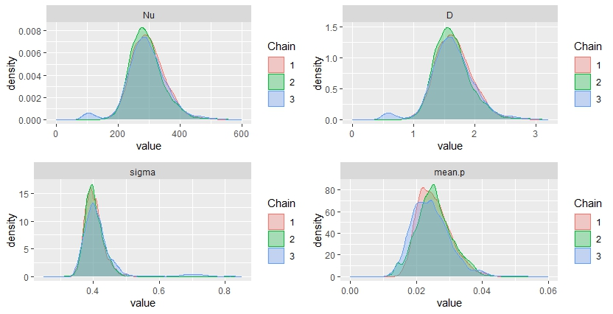

*Fig S2d: Distribution of posterior samples from 30,000 iterations of Bayesian, spatially explicit unmarked population models for lace monitors, derived from camera data on the mid-coast of NSW, Australia. Nu = estimated number of individuals, D = density, sigma = a parameter related to home range, mean.p = detection probability intercept.*

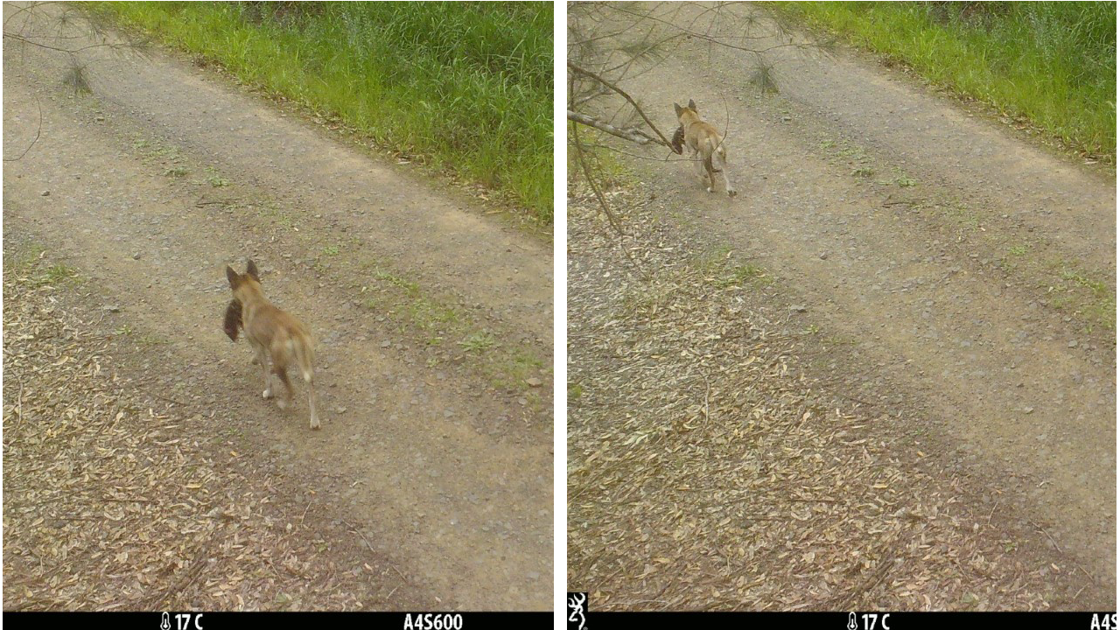

*Figure S3: A dingo (Canis dingo, Canis lupus, Canis familiaris, amongst others) carrying a spotted-tailed quoll (Dasyurus maculatus), identified from a camera trapping survey in October 2020 in Myall Lakes National Park.*